Volatility correlation: USDJPY and USDCHF
Method 25 / daily |log returns| / rho_vol / Alpari D1 full available history (realized deferred)

Study setup
Logical pair: USDJPY , USDCHF
Broker symbols: USDJPY_i , USDCHF_i
Snapshot: 2026-11-03_majors_alpari_D1
Timeframe: D1
Matched return window: 1999-01-05 to 2026-11-02 (UTC bar dates)
Matched return count n: 7185
Dropped unfinished last bar dated 2026-11-03 UTC after a tick-volume check against the prior complete day.
Statistic: rho_vol = Corr(|log return_L|, |log return_R|)
rho_realized: not computed (no intraday buckets in this snapshot)
Complete matched rows (Excel): USDJPY-USDCHF_Vol_D1.xlsx
Complete matched rows (HTML table): USDJPY-USDCHF_Vol_D1_data.html

Method carried forward
Volatility correlation rho_vol = Corr(|x_t|, |y_t|) measures whether absolute daily log returns of close move together in size, regardless of sign. Quotes are not inverted. Same-sample signed Pearson r is a side check. The formula sheet also defines within-day realized correlation rho_realized,d from intraday buckets; this v001 uses the Alpari D1 snapshot only, so rho_realized is not computed (no intraday buckets). This is not causation and not a trading signal.

Results (headline)
rho_vol: 0.276663
Pearson r (signed): 0.399461
mean |USDJPY|: 0.00444794
mean |USDCHF|: 0.00451484
rho_realized: n/a (D1-only snapshot)

Conclusion
Headline rho_vol for USDJPY and USDCHF: 0.2767. Signed Pearson r = 0.3995. Mean |return|: 0.004448 (USDJPY), 0.004515 (USDCHF). rho_realized not computed (D1 snapshot has no intraday buckets). This is absolute-move co-movement, not a trading signal.

Charts
Daily closes

Daily log returns

Absolute returns scatter
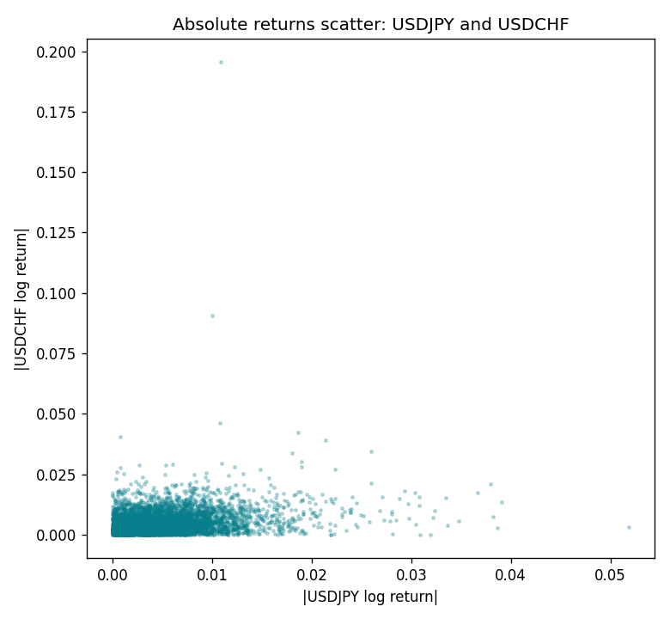

Data report
Matched rows are in the sibling Excel workbook named USDJPY-USDCHF_Vol_D1.xlsx. Embedding all rows as a Word table is impractical; this file holds column summaries and the first and last 15 matched rows.
Columns: time, USDJPY_open, USDCHF_open, USDJPY_high, USDCHF_high, USDJPY_low, USDCHF_low, USDJPY_close, USDCHF_close, USDJPY_tick_volume, USDCHF_tick_volume, USDJPY_spread, USDCHF_spread, USDJPY_real_volume, USDCHF_real_volume, USDJPY_log_return, USDCHF_log_return, USDJPY_abs_return, USDCHF_abs_return
Column summaries (matched calculation rows)
column | count | mean | std | min | 25% | 50% | 75% | max
USDJPY_open | 7185 | 113.80726 | 19.2236 | 75.693 | 104.38 | 110.984 | 120.69 | 163.824
USDCHF_open | 7185 | 1.0974395 | 0.25223318 | 0.72022 | 0.92053 | 0.98988 | 1.2375 | 1.8219
USDJPY_high | 7185 | 114.30433 | 19.285132 | 76.001 | 104.865 | 111.442 | 121.257 | 163.978
USDCHF_high | 7185 | 1.1027315 | 0.25397793 | 0.73305 | 0.92474 | 0.99353 | 1.2422 | 1.8313
USDJPY_low | 7185 | 113.28455 | 19.151449 | 75.402 | 103.87 | 110.53 | 120.17 | 163.628
USDCHF_low | 7185 | 1.0923205 | 0.25064913 | 0.08565 | 0.91719 | 0.98622 | 1.2315 | 1.8121
USDJPY_close | 7185 | 113.82023 | 19.238853 | 75.811 | 104.38 | 111.025 | 120.68 | 163.851
USDCHF_close | 7185 | 1.0974333 | 0.25214008 | 0.72025 | 0.92079 | 0.98995 | 1.2376 | 1.8217
USDJPY_tick_volume | 7185 | 106345.59 | 179437.4 | 149 | 9958 | 53202 | 92889 | 1803508
USDCHF_tick_volume | 7185 | 74334.331 | 113494.7 | 18 | 12809 | 40241 | 70443 | 858589
USDJPY_spread | 7185 | 20.263883 | 17.612444 | 0 | 6 | 11 | 30 | 50
USDCHF_spread | 7185 | 26.03215 | 24.694045 | 0 | 5 | 16 | 50 | 100
USDJPY_real_volume | 7185 | 3.4781051e+10 | 1.6093614e+11 | 0 | 0 | 0 | 0 | 3.8834203e+12
USDCHF_real_volume | 7185 | 2.3294091e+10 | 8.9133595e+10 | 0 | 0 | 0 | 0 | 1.9331921e+12
USDJPY_log_return | 7185 | 4.82e-05 | 0.00620617 | -0.03908203 | -0.00320044 | 0.00011473 | 0.00340924 | 0.05184024
USDCHF_log_return | 7185 | -6.962e-05 | 0.0065941 | -0.19545699 | -0.0033516 | 8.06e-05 | 0.00332472 | 0.09051364
USDJPY_abs_return | 7185 | 0.00444794 | 0.00432803 | 0 | 0.00143199 | 0.00330607 | 0.00619586 | 0.05184024
USDCHF_abs_return | 7185 | 0.00451484 | 0.00480628 | 0 | 0.00150848 | 0.0033336 | 0.0062318 | 0.19545699
First 15 matched rows (selected columns)
time | USDJPY_log_return | USDCHF_log_return | USDJPY_abs_return | USDCHF_abs_return
1999-01-05 | -0.00017868311 | 0.0039424743 | 0.00017868311 | 0.0039424743
1999-01-06 | 0.0075660159 | 0.013605652 | 0.0075660159 | 0.013605652
1999-01-07 | -0.012851583 | -0.0093883841 | 0.012851583 | 0.0093883841
1999-01-08 | -0.0047719894 | 0.011040268 | 0.0047719894 | 0.011040268
1999-01-11 | -0.016195423 | 0.0052963193 | 0.016195423 | 0.0052963193
1999-01-12 | 0.032310364 | -0.0098275602 | 0.032310364 | 0.0098275602
1999-01-13 | 0.0081373171 | -0.018259701 | 0.0081373171 | 0.018259701
1999-01-14 | 0 | -0.0024256692 | 0 | 0.0024256692
1999-01-15 | 0.0055343401 | 0.01794228 | 0.0055343401 | 0.01794228
1999-01-18 | 8.7600193e-05 | -0.0031856384 | 8.7600193e-05 | 0.0031856384
1999-01-19 | -0.0056219403 | -7.2518946e-05 | 0.0056219403 | 7.2518946e-05
1999-01-20 | -0.0053879917 | 0.0072259871 | 0.0053879917 | 0.0072259871
1999-01-21 | 0.0084664056 | -0.0038232689 | 0.0084664056 | 0.0038232689
1999-01-22 | 0.0060412564 | -0.0001445609 | 0.0060412564 | 0.0001445609
1999-01-25 | -0.0073594164 | 0.0024546976 | 0.0073594164 | 0.0024546976
Last 15 matched rows (selected columns)
time | USDJPY_log_return | USDCHF_log_return | USDJPY_abs_return | USDCHF_abs_return
2026-10-13 | -0.0018932826 | -0.0024955621 | 0.0018932826 | 0.0024955621
2026-10-14 | 7.5800166e-05 | 0.0029388325 | 7.5800166e-05 | 0.0029388325
2026-10-15 | -0.0018524319 | -0.0097855323 | 0.0018524319 | 0.0097855323
2026-10-16 | -0.00037976126 | -0.0036230826 | 0.00037976126 | 0.0036230826
2026-10-19 | 0.0034946841 | 0.0036351779 | 0.0034946841 | 0.0036351779
2026-10-20 | -0.0022546642 | -0.0026281224 | 0.0022546642 | 0.0026281224
2026-10-21 | -0.00032883504 | -0.00040027413 | 0.00032883504 | 0.00040027413
2026-10-22 | -0.0085942669 | -0.0048036381 | 0.0085942669 | 0.0048036381
2026-10-23 | 0.00035080446 | 0.005652514 | 0.00035080446 | 0.005652514
2026-10-26 | 0.0041238746 | 0.0018407959 | 0.0041238746 | 0.0018407959
2026-10-27 | 0.0027651658 | 0.0026100526 | 0.0027651658 | 0.0026100526
2026-10-28 | -0.00095679538 | -0.0010142111 | 0.00095679538 | 0.0010142111
2026-10-29 | -0.00038043789 | -0.0048680164 | 0.00038043789 | 0.0048680164
2026-10-30 | -0.0010596481 | 0.00071594559 | 0.0010596481 | 0.00071594559
2026-11-02 | 0.0026438521 | -0.0071459744 | 0.0026438521 | 0.0071459744

